EXPERIMENT NO: 9
Title:
Number Plate Detection and Recognition System

Aim:
To develop an end-to-end deep learning-based application that detects and recognizes vehicle number plates from images through a simple web UI.

Objectives:
- Implement a YOLOv5-based object detection pipeline to localize number plates in input images.
- Integrate EasyOCR to perform optical character recognition on the cropped number plate regions.
- Build a Streamlit web interface to allow users to upload vehicle images and view detection results interactively.
- Ensure the system properly handles typical scenarios, including varying plate sizes, angles, and lighting conditions.
- Organize project artifacts, dependencies, and outputs using best practices (e.g., .gitignore, folder structure).

Theory:
- Object Detection with YOLOv5
  - YOLO (You Only Look Once) is a one-stage object detection algorithm that predicts bounding boxes and class probabilities in a single evaluation.
  - YOLOv5 improves on earlier versions with architectural refinements in the backbone (Cross Stage Partial networks) and neck (Path Aggregation Network), leading to faster inference and higher accuracy.
  - Inference involves passing an image through the model, obtaining predictions (results.), and filtering by confidence threshold to localize the plate region.
- Optical Character Recognition (OCR) with EasyOCR
  - OCR converts image text into machine-encoded text. EasyOCR leverages deep convolutional recurrent neural networks to handle multilingual text detection and recognition.
  - After cropping the detected plate region, EasyOCR’s reader.readtext() analyzes the image patch, outputs bounding boxes, recognized text, and confidence scores.
- Streamlit UI
  - Streamlit provides a declarative API for building data apps; st.file_uploader lets users upload images, st.image displays them, and control structures in app.py orchestrate the detection pipeline.
  - Folder management (uploads/, results/) ensures persistence of input and output files, facilitating reproducibility and debugging.
- Project Organization and Best Practices
  - Dependencies are managed via requirements.txt and Python virtual environments (e.g., .venv).
  - .gitignore excludes temporary files, model artifacts (*.pt, YOLOv5 runs), upload/result directories, and environment folders to keep the repository clean.

Code:
import streamlit as st
import cv2
import torch
import numpy as np
import easyocr
import os
from PIL import Image

# Load YOLOv5 model
model = torch.hub.load('ultralytics/yolov5', 'yolov5s', pretrained=True)
model.conf = 0.4 # confidence threshold

# Initialize EasyOCR reader
reader = easyocr.Reader(['en'])

# Create folders if they don't exist
os.makedirs("uploads", exist_ok=True)
os.makedirs("results", exist_ok=True)

st.title("🚘 Number Plate Detection with OCR")

# File uploader
uploaded_file = st.file_uploader("Upload an image of a car", type=["jpg", "png", "jpeg"])

if uploaded_file is not None:
# 1. Save the uploaded image
upload_path = os.path.join("uploads", uploaded_file.name)
with open(upload_path, "wb") as f:
f.write(uploaded_file.getbuffer())

# 2. Display the uploaded image
st.image(upload_path, caption="Uploaded Image", use_container_width=True)

# 3. Run detection
img = np.array(Image.open(upload_path).convert("RGB"))
results = model(img)

# 4. Render detections onto the image
annotated = results.render()[0] # returns a list; take first element
# YOLOv5 renders in BGR, convert to RGB
annotated_rgb = cv2.cvtColor(annotated, cv2.COLOR_BGR2RGB)

# 5. Save the annotated image to results/
result_path = os.path.join("results", uploaded_file.name)
Image.fromarray(annotated_rgb).save(result_path)

# 6. Display the annotated (detected) image
st.image(result_path, caption="Detected Plates", use_container_width=True)

# 7. Perform OCR on each detected bounding box
st.subheader("📖 Detected Plate Text:")
for i, det in enumerate(results.xyxy[0]):
x1, y1, x2, y2 = det[:4].int().tolist()
crop = img[y1:y2, x1:x2]
if crop.size:
ocr_results = reader.readtext(crop)
for _, text, _ in ocr_results:
st.success(f"Plate {i+1}: {text}")

st.info("✅ Done! Upload another image to detect more plates.")

Output:
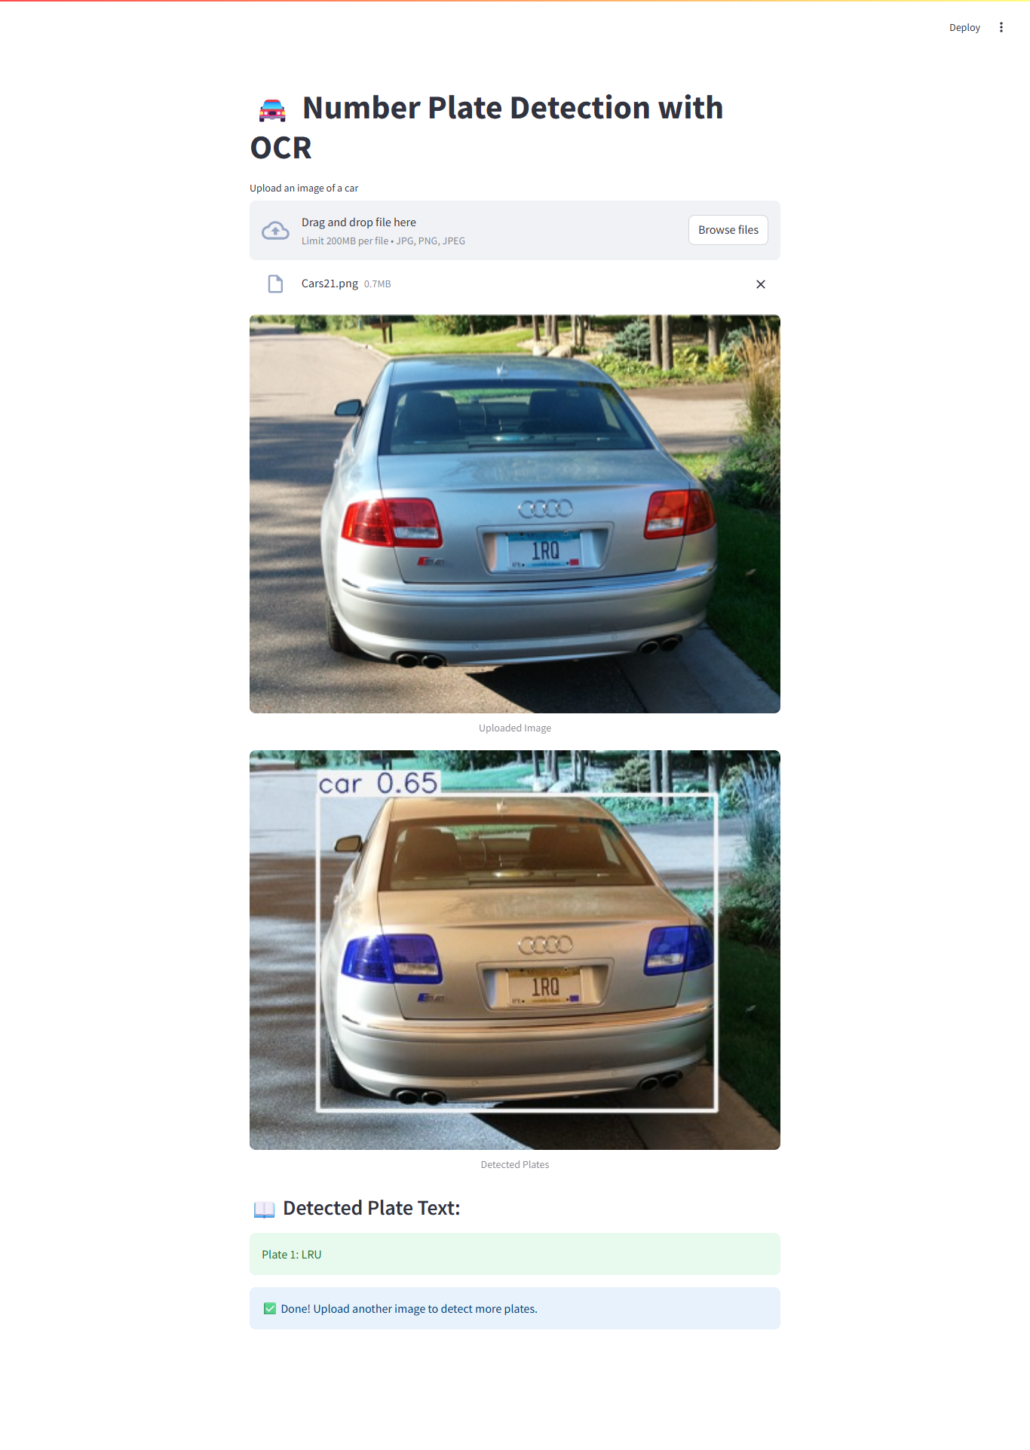

Conclusion:
This project demonstrates a streamlined workflow for vehicle number plate detection and recognition by combining state-of-the-art deep learning and OCR techniques within a user-friendly Streamlit interface. YOLOv5 effectively localizes license plates in diverse conditions, while EasyOCR accurately extracts alphanumeric text from the detected regions. The modular design—from image upload to result visualization—ensures ease of use and extensibility. By adhering to best practices for code organization, environment management, and version control, the solution is maintainable and ready for further enhancements, such as custom training on domain-specific datasets or integration into real-time video streams.

